EXP. NO:3
MATLAB-BASED MODELLING OF VSB MODULATOR AND DEMODULATOR FOR ANALOG TELEVISION COMMUNICATION APPLICATIONS
Objectives:
i) To generate and analyse the Vestigial Sideband (VSB) modulated signal by performing
DSB-SC modulation and applying a suitable filter using MATLAB.
PROGRAMMING CODE:
clc;
clear;
close all;

% Parameters
Am = 1; % Message amplitude
fm = 500; % Message frequency (Hz)
Ac = 5; % Carrier amplitude
fc = 5000; % Carrier frequency (Hz)
fs = 100000; % Sampling frequency
T = 0.02; % Signal duration

% Time vector
t = 0:1/fs:T-1/fs;
N = length(t);

% Message signal
m = Am*cos(2*pi*fm*t);

% Carrier signal
c = Ac*cos(2*pi*fc*t);

% DSB-SC modulation
dsb_sc = m .* c;

% Frequency axis
f = (-N/2:N/2-1)*(fs/N);

% Frequency spectrum of DSB-SC
DSB_FFT = abs(fftshift(fft(dsb_sc)))/N;

% Design VSB filter in frequency domain
H = zeros(1,N);

% Keep the positive-frequency sideband around the carrier.
% Retain the full USB and a portion of the LSB.
for k = 1:N
if abs(f(k)) >= fc && abs(f(k)) <= fc + fm
H(k) = 1;
elseif abs(f(k)) >= fc - fm && abs(f(k)) < fc
H(k) = 0.5;
elseif abs(f(k)) >= -(fc + fm) && abs(f(k)) <= -fc
H(k) = 1;
elseif abs(f(k)) > -fc && abs(f(k)) <= -(fc - fm)
H(k) = 0.5;
end
end

% Apply VSB filter
DSB_FFT_complex = fftshift(fft(dsb_sc));
VSB_FFT_complex = DSB_FFT_complex .* H;
vsb = real(ifft(ifftshift(VSB_FFT_complex)));

% VSB frequency spectrum
VSB_FFT = abs(fftshift(fft(vsb)))/N;

% Plot signals and spectra
figure('Name','VSB Modulation Analysis','NumberTitle','off');

subplot(3,2,1);
plot(t,m);
title('Message Signal');
xlabel('Time (s)');
ylabel('Amplitude');
grid on;

subplot(3,2,2);
plot(t,dsb_sc);
title('DSB-SC Modulated Signal');
xlabel('Time (s)');
ylabel('Amplitude');
grid on;

subplot(3,2,3);
plot(f,DSB_FFT);
xlim([fc-2*fm fc+2*fm]);
title('DSB-SC Frequency Spectrum');
xlabel('Frequency (Hz)');
ylabel('Magnitude');
grid on;

subplot(3,2,4);
plot(t,vsb);
title('VSB Modulated Signal');
xlabel('Time (s)');
ylabel('Amplitude');
grid on;

subplot(3,2,5);
plot(f,VSB_FFT);
xlim([fc-2*fm fc+2*fm]);
title('VSB Frequency Spectrum');
xlabel('Frequency (Hz)');
ylabel('Magnitude');
grid on;

subplot(3,2,6);
plot(f,H);
xlim([fc-2*fm fc+2*fm]);
title('VSB Filter Response');
xlabel('Frequency (Hz)');
ylabel('Magnitude');
grid on;
% Display information
fprintf('Message Frequency = %d Hz\n',fm);
fprintf('Carrier Frequency = %d Hz\n',fc);
fprintf('Lower Sideband Range = %d to %d Hz\n',fc-fm,fc);
fprintf('Upper Sideband Range = %d to %d Hz\n',fc,fc+fm);
fprintf('VSB signal generated successfully.\n');
OUTPUT:
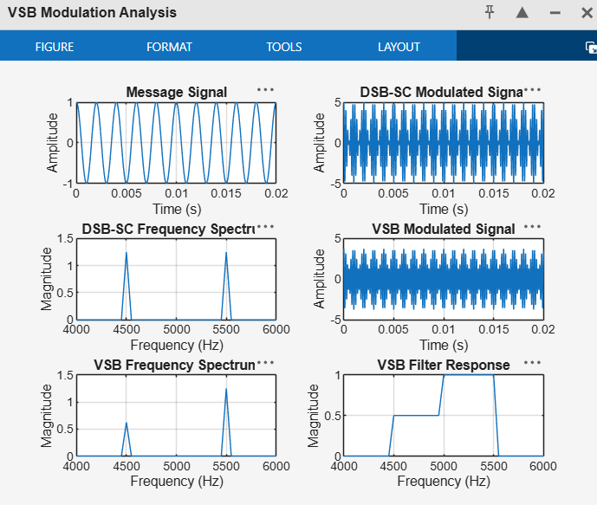
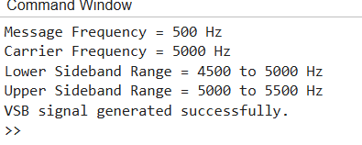
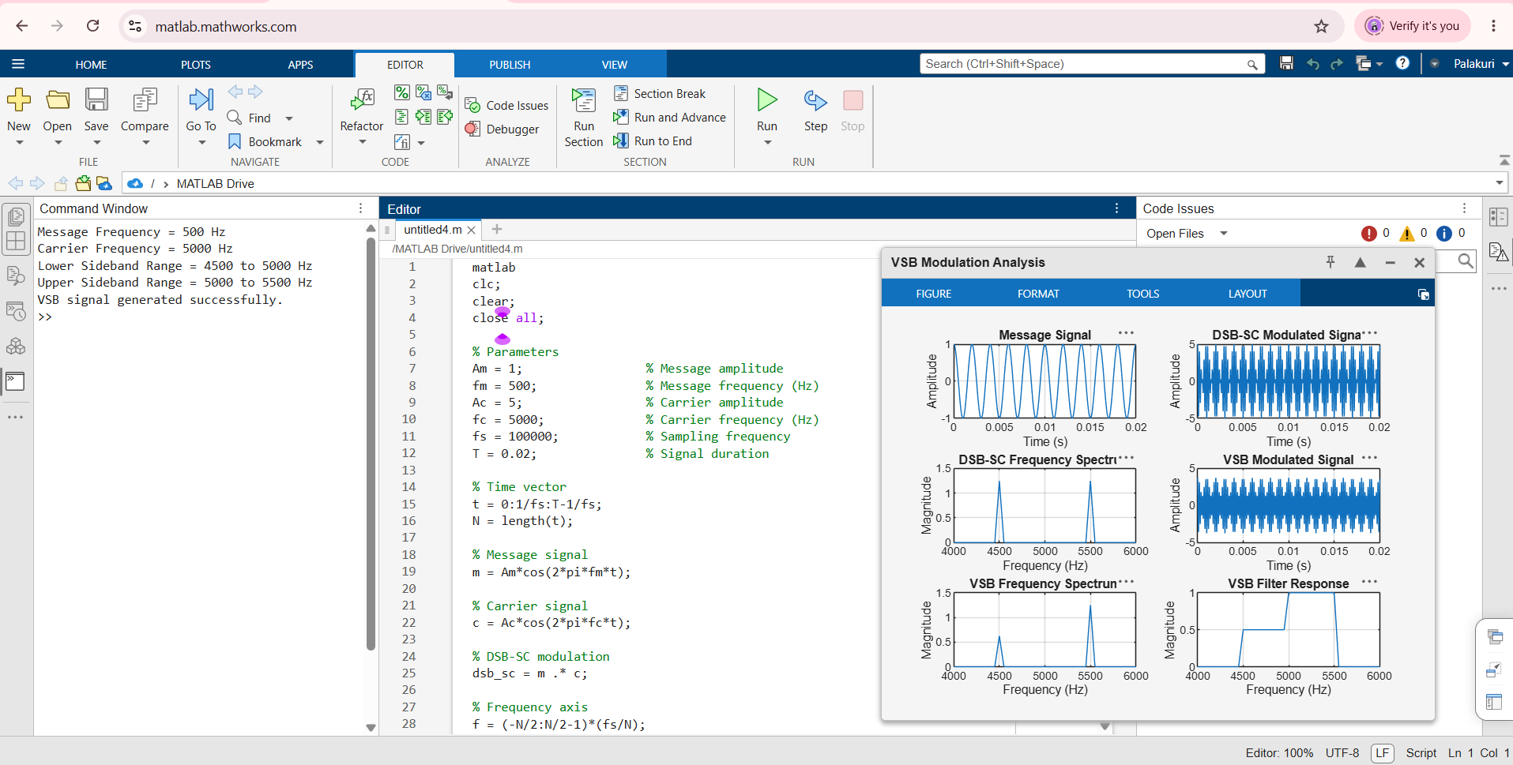
OBJECTIVE 2
ii) To implement coherent demodulation and recover the original message signal from the VSB
signal, and compare the transmitted and recovered waveforms.
PROGRAMMING CODE:
clc;
clear;
close all;
% Parameters
Am = 1; % Message amplitude
fm = 500; % Message frequency (Hz)
Ac = 5; % Carrier amplitude
fc = 5000; % Carrier frequency (Hz)
fs = 100000; % Sampling frequency
T = 0.02; % Signal duration
% Time vector
t = 0:1/fs:T-1/fs;
N = length(t);
% 1. Generate message signal
m = Am*cos(2*pi*fm*t);
% 2. Generate carrier signal
c = Ac*cos(2*pi*fc*t);
% 3. DSB-SC modulation
dsb_sc = m .* c;
% 4. Design simplified VSB filter
f = (-N/2:N/2-1)*(fs/N);
H = zeros(1,N);
% Retain USB and half of LSB
for k = 1:N
if abs(f(k)) >= fc && abs(f(k)) <= fc+fm
H(k) = 1;
elseif abs(f(k)) >= fc-fm && abs(f(k)) < fc
H(k) = 0.5;
elseif abs(f(k)) >= -(fc+fm) && abs(f(k)) <= -fc
H(k) = 1;
elseif abs(f(k)) > -fc && abs(f(k)) <= -(fc-fm)
H(k) = 0.5;
end
end
% Apply VSB filter
DSB_FFT = fftshift(fft(dsb_sc));
VSB_FFT = DSB_FFT .* H;
vsb = real(ifft(ifftshift(VSB_FFT)));
% 5. Coherent demodulation
% Multiply VSB signal by synchronized carrier
demod = vsb .* cos(2*pi*fc*t);
% 6. Low-pass filter to recover message
[b,a] = butter(5, 2*fm/fs);
recovered = filtfilt(b,a,demod);
% 7. Normalize recovered signal
recovered = recovered - mean(recovered);
recovered = recovered / max(abs(recovered));
% 8. Plot results
figure('Name','VSB Coherent Demodulation', ...
'NumberTitle','off');
subplot(3,1,1);
plot(t,m,'b','LineWidth',1.2);
title('Original Message Signal');
xlabel('Time (s)');
ylabel('Amplitude');
grid on
subplot(3,1,2);
plot(t,vsb,'r','LineWidth',1.2);
title('VSB Modulated Signal');
xlabel('Time (s)');
ylabel('Amplitude');
grid on
subplot(3,1,3);
plot(t,m,'b','LineWidth',1.5);
hold on;
plot(t,recovered,'r--','LineWidth',1.2);
title('Original and Recovered Message Signals');
xlabel('Time (s)');
ylabel('Normalized Amplitude');
legend('Original Message','Recovered Message');
grid on;
hold off;
% 9. Display result
fprintf('VSB coherent demodulation completed.\n');
fprintf('Message frequency = %d Hz\n',fm);
fprintf('Carrier frequency = %d Hz\n',fc);
OUTPUT:
